Supplementary material for
Binary mixtures of menthol and alkanoic acids as green solvents for efficient astaxanthin recovery from Aristaeomorpha foliacea shrimp shells
Federica Mancarella ª, Francesco Milano ^{b}, Paola Semeraro ^{a,1}, Vincenzo De Leo ^{c}, Francesco Messa ª, Serena Perrone ª, Antonio Salomone ^{c}, Miriana Durante ^{b}, Marcello Salvatore Lenucci ª, Maria De Benedictis ^{b}, Angelo Santino ^{b}, Livia Giotta ^{a,d}*, Ludovico Valli ^{a,d}
ª Dipartimento di Scienze e Tecnologie Biologiche e Ambientali, Università del Salento, S.P. Lecce-Monteroni, I-73100 Lecce, Italy
^{b} Istituto di Scienze delle Produzioni Alimentari (ISPA), Consiglio Nazionale delle Ricerche (CNR), UOS Lecce, S.P. Lecce-Monteroni, I-73100 Lecce, Italy
^{c} Dipartimento di Chimica, Università degli Studi di Bari “Aldo Moro”, Bari, Italy
^{d} Consorzio Interuniversitario Nazionale per la Scienza e Tecnologia dei Materiali (INSTM), Unità di Lecce, Lecce, Italy

* Corresponding author: livia.giotta@unisalento.it

¹ present address: Istituto di Scienze dell’Atmosfera e del Clima (ISAC), Consiglio Nazionale delle Ricerche (CNR), UOS Lecce, S.P. Lecce-Monteroni, I-73100 Lecce, Italy

Contents:

Text S1: Absorption maxima and extinction coefficients of standard astaxanthin in ME:C2n (n=1-5) mixtures.

Table S1: Wavelengths of maximum absorption and extinction coefficients of (all-E)-AST in acetone and in ME:C2n (n=1-5) mixtures.

Figure S1: Time course of the relative absorption intensity at the peak wavelength of the shrimp shell extracts obtained with acetone, ME:C10 and acetic acid kept in different conditions.

Figure S2: ATR-FTIR spectra of reference compounds and ME:C10 mixtures after interaction with an α-CD solution and distilled water.

Figure S3: ATR-FTIR spectra of dry films arising from casting/evaporation of the aqueous phase separated from the α-CD stabilized ME:C10-in-water emulsion and reference C10 aqueous solutions.

Text S1 - Absorption maxima and extinction coefficients of standard astaxanthin in ME:C2n (n=1-5) mixtures (ME:AA mixtures).
To assess the astaxanthin (AST) content of ME:AA extracts by visible spectroscopy, the wavelengths of absorption maxima and relevant molar extinction coefficients of standard AST were first determined in a conventional solvent (acetone) and in ME:AA mixtures. Three independent acetone solutions at a given concentration of synthetic (all-E)-AST were prepared and their absorption spectra were acquired in the range 300-700 nm. The absorption maximum appeared at 476 nm and the molar extinction coefficient at this wavelength was found to be 122 ± 3 mM⁻¹cm⁻¹. This value is in line with the percent extinction coefficient (A^{1%}) of 2100 100 mL g⁻¹cm⁻¹ (corresponding to 125 mM⁻¹cm⁻¹), which represents the rounded off average value employed by De Bruijn et al. [1]. Suitable aliquots of standard AST acetone solutions were withdrawn, and the solvent was evaporated by a gentle nitrogen stream. Then, each aliquot of the dried AST was dissolved in an equal volume of ME:AA mixtures and the visible spectrum of the resulting solution was recorded. The relevant molar extinction coefficient of AST at the wavelength of maximum absorption was obtained known the molar extinction coefficient in acetone at 476 nm, according to the following formula:
$$ε_{x,λ_{max}}= ε_{AC,476}\frac{A_{x,λ_{max}}}{A_{AC,476}}$$
where $ε_{x,λ_{max}}$ is the molar extinction coefficient of AST at the peak wavelength λ_{max} in the solvent x, $ε_{AC,476}$ is the molar extinction coefficient of AST at 476 nm in acetone, and $A_{x,λ_{max}}$ and $A_{AC,476}$are the peak absorbance values for AST solutions at the same concentration in the solvent x and in acetone respectively. The wavelengths of maximum visible absorption and relevant molar extinction coefficients in acetone and ME:AA mixtures are reported in Table S1. These results highlighted that the maximum absorption occurs at 486 nm for all the binary mixtures used to dissolve the standard (all-E)-AST. Furthermore, ANOVA analysis indicated no significant differences in extinction coefficient values among ME:C2n (n=1-5) mixtures (p > 0.05).

Table S1 - Wavelengths of maximum absorption (λ_{max}) and relevant extinction coefficients (ε_{λmax}) of standard (all-E)-AST in acetone and in ME:C2n (n=1-5) mixtures.
Solvent | λ_{max} (nm) | ε_{λmax} (mM⁻¹ cm⁻¹)
Acetone | 476 | 122 ± 3
ME:C2 | 486 | 123 ± 7
ME:C4 | 486 | 117 ± 5
ME:C6 | 486 | 112 ± 11
ME:C8 | 486 | 119 ± 6
ME:C10 | 486 | 117 ± 11

Figure S1 – Time course of the relative absorption intensity at the peak wavelength of the shrimp shell extracts obtained with acetone (black plot), ME:C10 (red plot) and acetic acid (blue plot) kept at 25 °C in the dark (A), at 60 °C in the dark (B) and at 25 °C in the light (C). The peak wavelengths were: 476 nm for acetone, 480 nm for ME:C10 and 477 nm for C2.
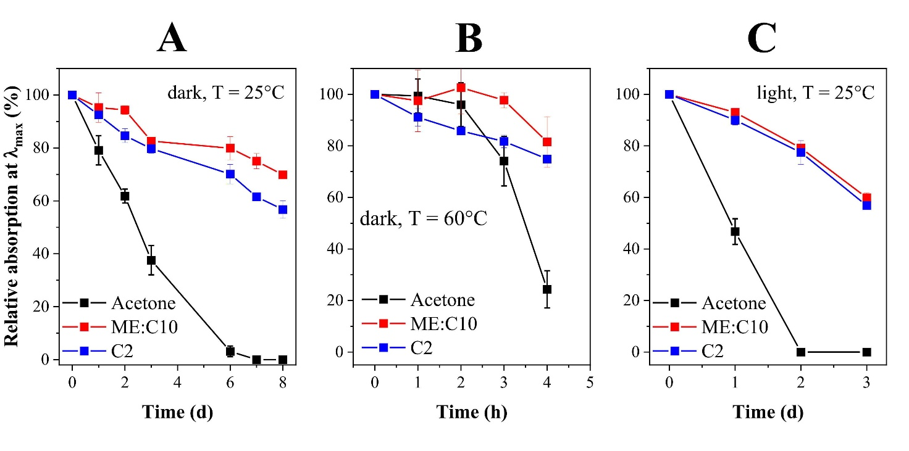

Figure S2 – ATR-FTIR spectra of menthol (a), decanoic acid (b), the upper layer separated by centrifugation of an α-CD stabilized ME:C10-in-water emulsion (c), the ME:C10 mixture vigorously stirred with distilled water and subsequently separated by centrifugation (d). (a) and (b) spectra were obtained by pressing onto the diamond the relevant pulverized solid compounds. (c) and (d) spectra were obtained layering 20 μL of the liquid samples.
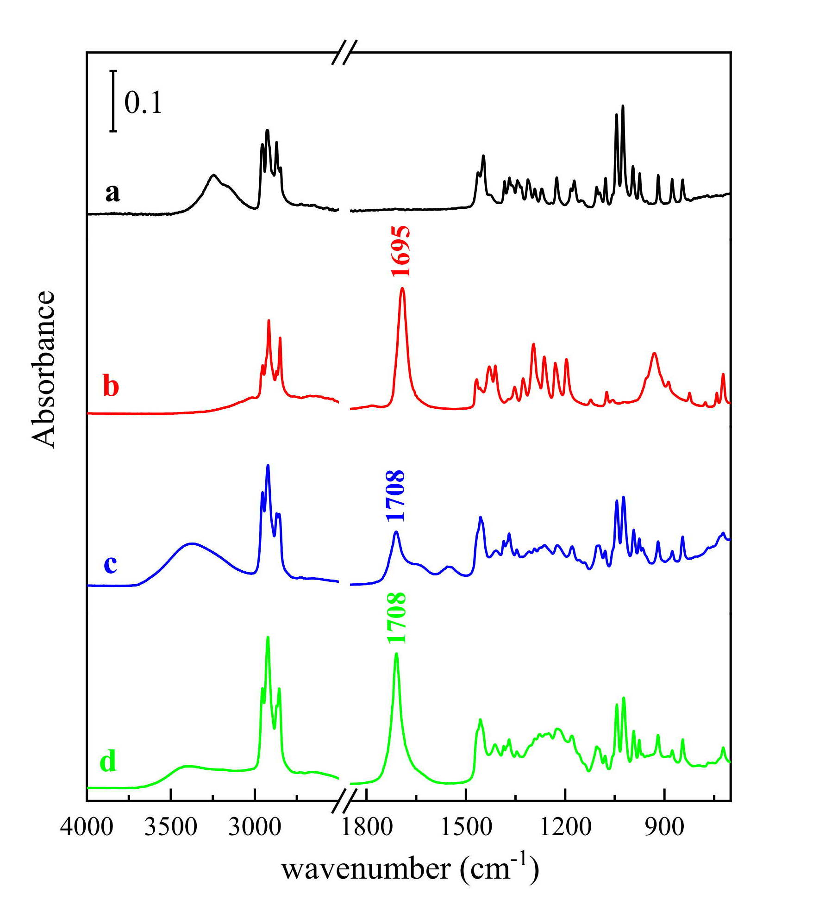

Figure S3 – ATR-FTIR spectra of dry films obtained by casting/evaporation of: (a) aqueous suspension prepared adding decanoic acid (0.056 g/mL final concentration) to a 0.1 g/mL α-CD solution, (b) decanoic acid aqueous solution (0.056 g/mL), (c) lower aqueous layer separated by centrifugation of an α-CD stabilized ME:C10-in-water emulsion.
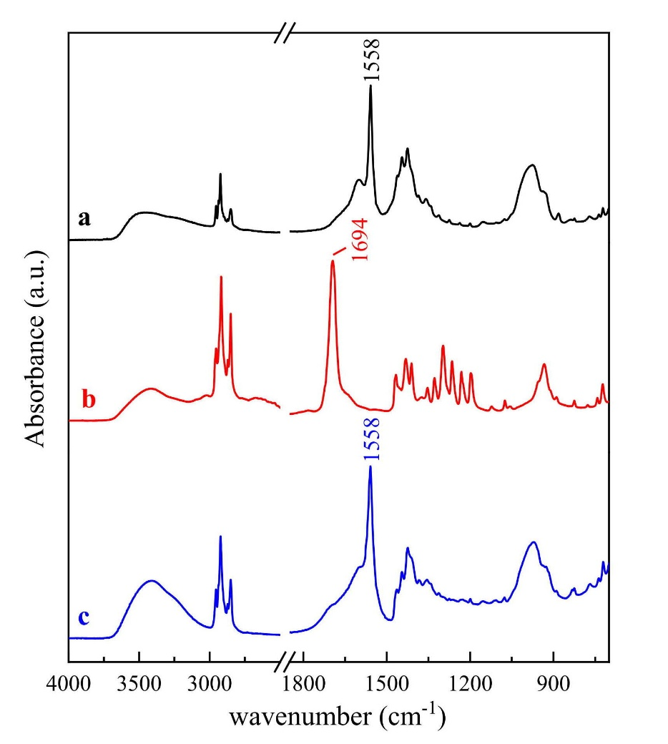

Reference
[1] W.J.C. De Bruijn, Y. Weesepoel, J.-P. Vincken, H. Gruppen, 2016. Fatty acids attached to all-trans-astaxanthin alter its cis–trans equilibrium, and consequently its stability, upon light-accelerated autoxidation. Food Chem. 194, 1108–1115 https://doi.org/10.1016/j.foodchem.2015.08.077

