Supporting Information

Direct evidence of the presence of hybrid charge transfer state in a perovskite nanocrystal - polythiophene blend solid state film
Tersilla Virgili*, Mariacecilia Pasini, Michele Guizzardi, Edoardo Mosconi, Stefania Milanese, Luca Gregori, Asma A. Alothman, Maria Luisa De Giorgi, Arianna Creti, Maryna Bodnarchuk, Mauro Lomascolo, Marco Anni*

Fig S1: PL relaxation dynamics at the PL peak wavelength of the NC (a) and P3HT (b), both for single materials and in NC-P3HT blend.

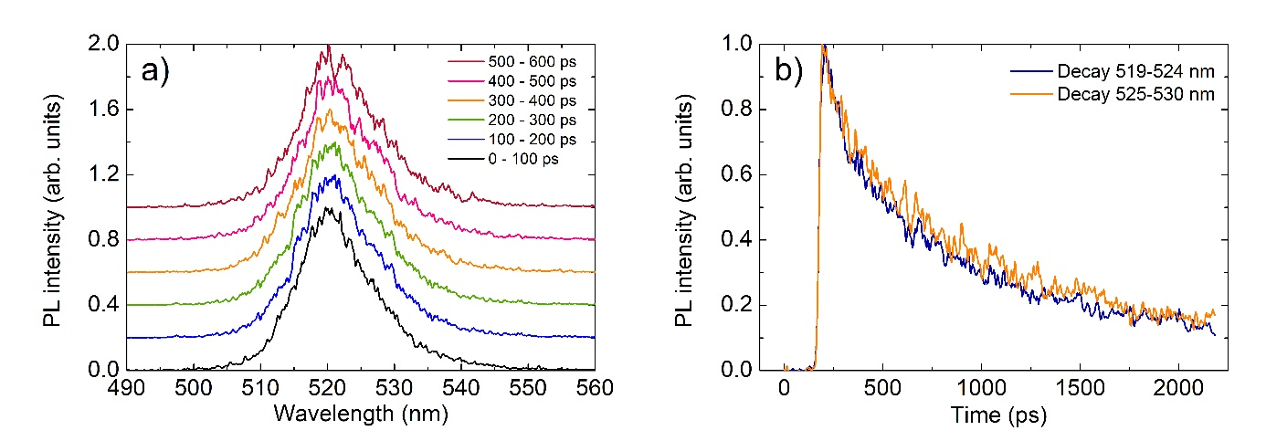
Figure S2 a) PL spectra in the NCs emission range in the blend as a function of the time after photoexcitation, evidencing the lack of any peak at higher wavelengths than the main peak. b): PL relaxation dynamics in 5 nm spectral windows around the PL peak (519-524 nm) and in the high wavelength tail of the spectrum, evidencing the lack of relaxation dynamics differences.

Figure S3 a) Pump-probe spectra at 1 ps (a) and 400 ps (b) probe delay for the NCs film (red line) and the NC-PFO blend (black line)

